**SEO ASSIGNMENT**

**Q1)What is SEO and explain the importance of SEO?**

Search engine optimization (SEO) is the practice of increasing the quantity and quality to teaffic to your website through organic search engine results.A higher rank when someone searches a term in your industry increases your brand’s visibility online. The increase in visibility will drive more organic traffic to your site and this in turn , gives you more oppurtunities to convert qualified prospects into customers.

SEO is important for brands as it’s a highly effective way to improve your brands visibility through search, drive more traffic to your website, establish your brand as a trusted authority in your industry, sustainability and reliably grow your business.These factor contributes to the importance of SEO-

* Visiblity and Rankings
* Web traffic
* Transworthy
* User experience
* Growth

**Q2)Create an HTML document with appropriate<title> and <meta> tags for SEO optimization,Ensure the title is descriptive and the meta description is concise.**

<!DOCTYPE html>

<html lang="en">

<head>

  <meta charset="UTF-8">

  <meta http-equiv="X-UA-Compatible" content="IE=edge">

  <meta name="viewport" content="width=device-width, initial-scale=1.0">

  <title>SEO -here we learn about seo</title>

  <meta

  name="title"

  content="SEO -here we learn about seo"/>

</head>

<body>

</body>

</html>

**Q3)what are the Benefits of using meta tags.**

Benefits of using meta tags-

When it comes to optimize your website .it is time to go through the benefits.

**1)Meta tags provides relevance**

Meta tags show search engine how relevant your page is to the user’s query.A query can be anything.As the information in the meta title tag indicates that the page is of the interest to the user , the search engine will deliver it an its results page , depending on the authority of the page.

**2)you save time without writing to much**

These are simple and to the point, whether you are writing a meta title or a meta description.These metadata are usually limited to a few words.

**3)They optimize your site without making things untidy**

Meta tags do not affect the actual ,visible content of your website in any way. This mens that they do not take up space which could be used for selling products or services,encouraging social engagement or presenting ideas.

**4)They can be quickly implemented**

There is no need for keyword research and strategy with constant updates on your search engine optimization as there are no keywords for meta tags.

**5)They allow you to track your metrics better**

It will ensure that all traffic to your website is legitimate and that the people who are looking for your content are the ones who find it therefore lessening your bounce rate and increasing the authority of your website.

**Q4)Create an HTML document that properly incorporates semantics elements like <header>,<article>,<section>,or <nav> to improve SEO and document structure.**

Solution:

<!DOCTYPE html>

<html lang="en">

<head>

  <meta charset="UTF-8">

  <meta http-equiv="X-UA-Compatible" content="IE=edge">

  <meta name="viewport" content="width=arti, initial-scale=1.0">

  <title>Document</title>

</head>

<body>

 <header>

  <h1>Here we learn about header, article ,section and nav  to improve SEO and document</h1>

  <article>

    <h2>Intoduction about SEO</h2>

    Search engine optimization (SEO) is the practice of orienting your website to rank higher on a search engine results page (SERP) so that you receive more traffic. The aim is typically to rank on the first page of Google results for search terms that mean the most to your target audience.

  </article>

 </header>

 <header>

  <h2>Here we learn about</h2>

  <nav>

    <ul>

    <li><a href="/">What is SEO?</a></li>

    <li><a href="/">How do search engines work?</a></li>

    <li><a href="/">Why SEO focuses on Google</a></li>

    <li><a href="/">What Google wants</a></li>

    <li><a href="/">How Google makes money</a></li>

    </ul>

  </nav>

  <section>

    <h3>About</h3>

    <p>

      SEO means Search Engine Optimization and is the process used to optimize a website's technical configuration, content relevance and link popularity so its pages can become easily findable, more relevant and popular towards user search queries, and as a consequence, search engines rank them better.

    </p>

  </section>

 </header>

 <footer>

  <p>&copy; 2024 Your Blog. All rights reserved.</p>

</footer

</body>

</html>

Ouput:

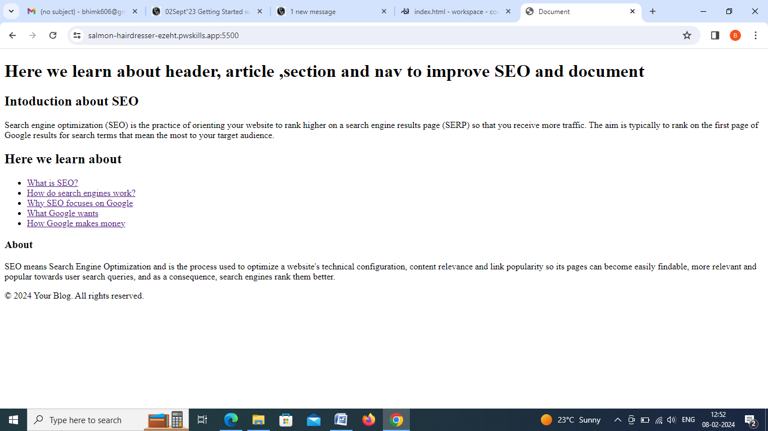

**Q5)Define favicon and give an illustrative example.**

Solution: -A favicon is a small website .Its main purpose as branding for your website.it’s main purpose is to help multiple tabs open.Due to their tiny size favicon work best as simple images or one-to-three character of text. Favicon are not to be confused with logos but are sometimes the same.Due to it’s small size and resolution,the favicon may need to be an even smaller size or part of a company’s original logo.

Favicon are found next to anything that identifies your website.This include bookmarks,tabs,toolbar apps,history,results,and search bars.

Example:

<!DOCTYPE html>

<html lang="en">

<head>

  <meta charset="UTF-8">

  <meta http-equiv="X-UA-Compatible" content="IE=edge">

  <meta name="viewport" content="width=device-width, initial-scale=1.0">

  <title>Document</title>

  <title>My Page Title</title>

  <link rel="icon" type="image/x-icon" href="/images/favicon.ico">

</head>

<body>

  <h1>Hellow world.</h1>

<p>Good morning</p>

</body>

</html>